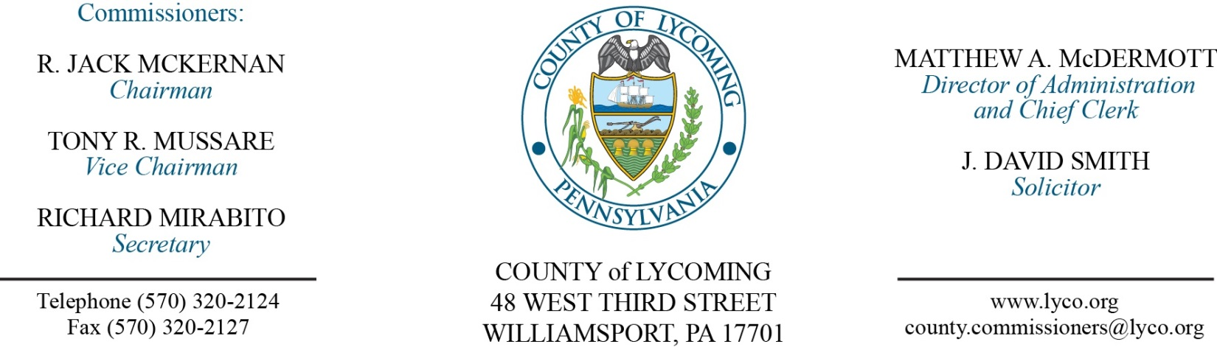
Commissioners’ Meeting Agenda
September 15, 2016

Opening Prayer

Pledge to the Flag

1.0 OPERATIONS

1.1 Convene Commissioners’ meeting.

1.2 Approve the minutes of the previous meetings.

1.3 Receive public comments (agenda items only).

2.0 ACTION ITEMS

2.1 Approve subrecipient monitoring contract with Lycoming County United Way for the Homeless Assistance Program in the amount of $153,114. (Michele McDermott)

2.2 Approve subrecipient monitoring contract with West Branch Drug & Alcohol for the Behavioral Health Services Initiative in the amount of $507,485. (Michele McDermott)

2.3 Approve subrecipient monitoring contract with West Branch Drug & Alcohol for Act 152 in the amount of $215,235. (Michele McDermott)

2.4 Approve quote from Sunbury Motor Company in the amount of $12,041.54 for repairs to the 2010 Western Star 4964F Semi Truck Tractor. (Michele McDermott)

2.5 Approve professional service agreement with Tioga County for JPO. (Nancy Ackley)

2.6 Approve professional service agreement with Clear Vision for JPO. (Nancy Ackley)

2.7 Approve updated payment to the Actuarially Determined Employer Contribution (ADEC) for 2016 increasing it by $316,551 for the new total amount of $2,304,865.

2.8 Approve the following personnel action: (Roxanne Grieco)
Domestic Relations – Julie A. Ault as full time replacement Clerk I – Pay grade 2 - $11.67/hour effective 9/19/16

5.0 REPORTS/INFORMATION ITEMS

5.1 Present retirement clock to Andrew Lutz from Pre Release. (Kevin Deparlos)

6.0 PUBLIC COMMENT:

7.0 NEXT REGULARLY SCHEDULED MEETING: Planning Session on Tuesday, September 20, 2016.

8.0 ADJOURN COMMISSIONERS’ MEETING.

